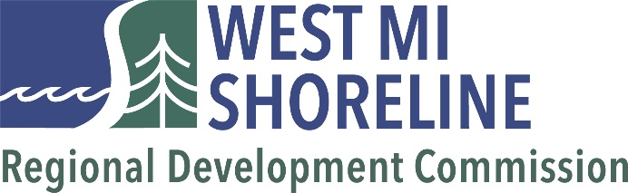

May 18, 2026 - 10:00 AM
Lake County Board Room
800 10th St, Baldwin, MI 49304

I. CALL TO ORDER

- ROLL CALL

- APPROVAL OF AGENDA (Page #) - ACTION ITEM

- APPROVAL OF MINUTES
        - Commission Minutes – March 23, 2026 (Page #) - ACTION ITEM
        - Elected Officers Minutes – April 27, 2026 (Page #) – INFORMATION

- PUBLIC COMMENT - AGENDA ITEMS

- CHAIRPERSON’S REPORT – INFORMATION

- EXECUTIVE DIRECTOR’S REPORT (Page #)

- FINANCIAL STATEMENTS – ACTION ITEM
        - April 2026 Financials
        - FY27 Preliminary Budget Discussion

- STAFF PRESENTATION - TBD

- NEW BUSINESS

- PUBLIC COMMENT – WMSRDC PROGRAMS

- ROUND TABLE

- ADJOURNMENT

NEXT MEETING: July 27, 2026 | Oceana County

